Week 5
- Write a Java program to insert 10, 20, 30 ....in an array and display them.
Program:
package week5;
import java.util.Scanner;
public class arrayinput{
public static void main(String[] args){
Scanner input=new Scanner(System.in);
int array[]=new int[3];
for(int i=0;i<3;i++){
System.out.print("Enter Integer-"+(i+1)+": ");
array[i]=input.nextInt();
}
System.out.print("Entered Integers are: ");
for(int i=0;i<3;i++){
System.out.print(array[i]+" ");
}
}
}
Output:
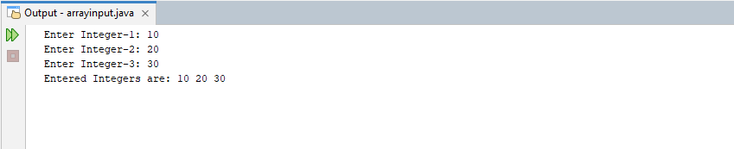

- Write a Java program to calculate the sum of all the array elements.
Program:
package week5;
public class sumofarray{
public static void main(String[] args){
int[] array={10,20,30,40,50};
int sum=0;
for(int i=0;i<5;i++){
sum+=array[i];
}
System.out.print("Sum of all elements of the array: "+sum);
}
}
Output:
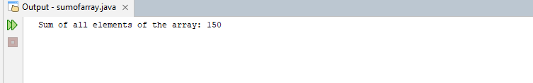

- Write a java program to print the following pattern.
1
12
123
1234
12345

Program:
package week5;
public class numpattern{
public static void main(String[] args){
for(int i=0;i<5;i++){
int x=1;
for(int j=0;j<5;j++){
if(i+j<4){
System.out.printf(" ");
}
else{
System.out.printf("%d",x);
x++;
}
}
System.out.printf("\n");
}
}
}
Output:
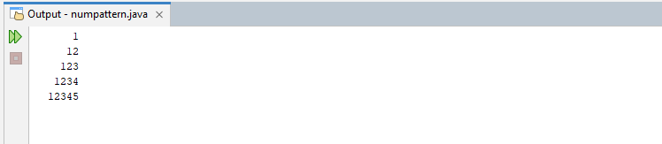

- Write a java program to find the sum of following series where n is input by the user.
1+1/2+1/3+1/4+...............+1/n.
Program:
package week5;
import java.util.Scanner;
public class sumofharmonicseries{
public static void main(String[] args){
Scanner input=new Scanner(System.in);
System.out.print("Enter n for nth term of the harmonic series: ");
int n=input.nextInt();
double sum=0;
for(double i=1.0;i<=n;i++){
double x=1/i;
sum+=x;
}
System.out.print("Sum of first "+n+" terms of harmonic series is: "+sum);
}
}
Output:
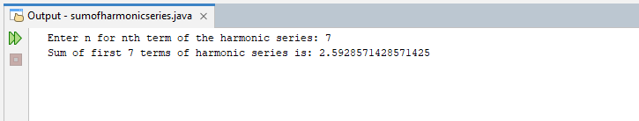

- Write a Java program and compute the sum of the digits of an integer.
Program:
package week5;
import java.util.Scanner;
public class sumofdigits{
public static void main(String[] args){
Scanner input=new Scanner(System.in);
System.out.print("Enter a positive integer: ");
int num=input.nextInt();
int lsd, sum=0;
while(num!=0){
lsd=num%10;
sum+=lsd;
num/=10;
}
System.out.print("Sum of all digits is: "+sum);
}
}
Output:
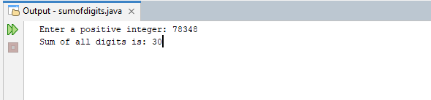

- Write a Java program to calculate the factorial of a number.
Program:
package week5;
public class factorial {
public static void main(String args[]) {
int num=10; int fact=num;
for(int i=2;i<num;i++){
fact*=i;
}
System.out.println("Factorial of "+num+" is "+fact);
}
}
Outcome:
